Andrew Ha  
COMP 352

# Class Specifications

|  |  |  |  |  |
| --- | --- | --- | --- | --- |
| Class | Abstract | Implements Abstract | Methods | Method Description |
| HashTable | Yes | No | HashTable  Input – int N  Size to initialize array to | Constructor, for the child classes.  Takes in a number to create the hash table size |
|  |  |  | Size  Input: None  Output: Size of hash table | Returns the current size (number of elements) in the hash table |
|  |  |  | Get Input K: Key is to be searched for in hash table  Output: MapElement object if a matching key is found.  Null otherwise | Abstract method for other child classes to inherit.  Given a key it will attempt to look for the element |
|  |  |  | Get Input K: Key is to be inputted for in hash table  Output: MapElement object if a matching key is found.  Null otherwise | Abstract method for other child classes to inherit. Will attempt to place an element given a key |
|  |  |  | Remove Input K: Key to be searched for in the table  Output: String Value of element that is be removed | Abstract Method for other child classes to inherit. Will attempt to remove an element |
| HashLinear | No | Yes | HashLinear  Input – int N  Size to initialize array to | Constructor, HashLinear class. Calls the super constructer of HashTable |
|  |  |  | Size  Input: None  Output: Size of hash table | Returns the current size (number of elements) in the hash table. Called from HashTable |
|  |  |  | Get Input K: Key is to be searched for in hash table  Output: MapElement object if a matching key is found.  Null otherwise | Given a key it will attempt to look for the element.  Implements linear probing |
|  |  |  | Get Input K: Key is to be inputted for in hash table  Output: MapElement object if a matching key is found.  Null otherwise | Will attempt to place an element given a key  Implements linear probing |
|  |  |  | Remove Input K: Key to be searched for in the table  Output: String Value of element that is be removed | Will attempt to remove an  Element.  Implements linear probing |
| HashQuadratic | No | Yes | HashQuadratic  Input – int N  Size to initialize array to | Constructor, HashLinear class. Calls the super constructer of HashTable |
|  |  |  | Size  Input: None  Output: Size of hash table | Returns the current size (number of elements) in the hash table. Called from HashTable |
|  |  |  | Get Input K: Key is to be searched for in hash table  Output: MapElement object if a matching key is found.  Null otherwise | Given a key it will attempt to look for the element.  Implements Quadratic Probing |
|  |  |  | Get Input K: Key is to be inputted for in hash table  Output: MapElement object if a matching key is found.  Null otherwise | Will attempt to place an element given a key  Implements Quadratic Probing |
|  |  |  | Remove Input K: Key to be searched for in the table  Output: String Value of element that is be removed | Will attempt to remove an  Element.  Implements Quadratic Probing |
| HashChaining | No | Yes | HashQuadratic  Input – int N  Size to initialize array to | Constructor, HashLinear class. Calls the super constructer of HashTable |
|  |  |  | Size  Input: None  Output: Size of hash table | Returns the current size (number of elements) in the hash table. Called from HashTable |
|  |  |  | Get Input K: Key is to be searched for in hash table  Output: MapElement object if a matching key is found.  Null otherwise | Given a key it will attempt to look for the element.  Implements Hash Chaining |
|  |  |  | Get Input K: Key is to be inputted for in hash table  Output: MapElement object if a matching key is found.  Null otherwise | Will attempt to place an element given a key  Implements Hash Chaining |
|  |  |  | Remove Input K: Key to be searched for in the table  Output: String Value of element that is be removed | Will attempt to remove an  Element.  Implements Hash Chaining |
| MapElement | No | No | MapElement | Constructor. Randomly generates a key. And sets its value to a string involving the key |
| MapElement | No | No | HashCode | Overrides HashCode. Using Horners rule to implement a hash code based on its key |

## Design Decisions

I tried to make my best to make the classes abstract. At first my design isn’t the most modular unfortunately, and given the chance, I should’ve made methods to look for the index in another method, and just reused more methods. Nonetheless, common functionality such as Size and Contructor were kept in the Abstract class as well as the class variables. There were quite a bit of duplicate code between the classes due to lack of time, and not as much foresight into the assignment. I decided to give the linear/quadratic probing and searches approximately the size of N x 5 times before it doesn’t have enough time.

# Report Times:

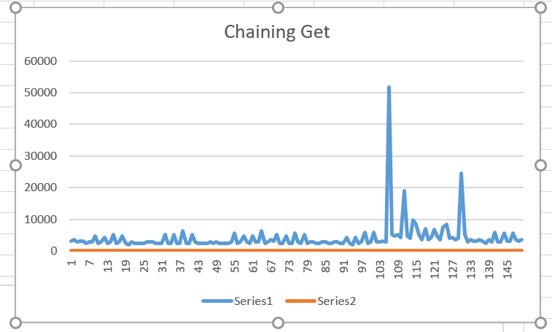

# Analysis

The graphs all appear to increase in size with each insert. This is because of more and more collisions happening. The linear probing takes the longest, quadratic second longest and the one with buckets is a decent speed.

The reason why some of these methods take an excessive time is due to the hash table running out of room and having to probe. It happens because the quadratic probing might take a long time to look for a location once it ran out of room.

Rerunning the experiment for quadratic probing reveals less time. This is because 101 is a prime number therefore the chances of collisions is reduced.

Benchmarking the cost of dynamic resizing., the cost of a put and a get is at least 2-3x more expensive when we are dynamically resizing the table. I got a lot more exceptions when I was trying to probe with quadratic probing as well.